Jessica Paul
6/21/2026
CS320 Project Two
Summary
In order to test the code of the application for errors, I used JUnit testing. This is a comprehensive method of testing code that is both efficient and reliable for smaller applications like this. Every deliverable had specific requirements that needed to be met. Using JUnit testing we could test these requirements in an easy and reliable way. For example, in the Contact class, the Contact ID could not be longer than 10 characters. When creating the Contact object, we could do this by using a line of code like this.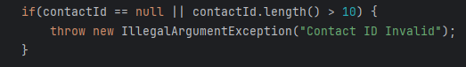
We would then use JUnit testing to test and see if the program would throw an error if we tried to use a Contact ID that was too long. If an error was thrown, the test will pass. This test looks like this. 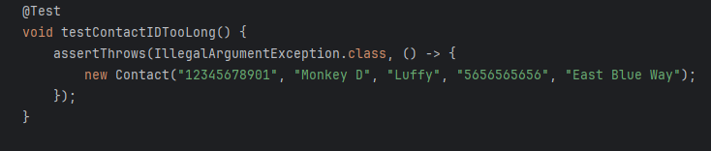
Doing this for all of the requirements would ensure that the code properly aligned with the requirements. As long as the JUnit tests covered over eighty percent of the code, they could be considered effective. Every function within my code had a Junit test to match, so this ensured that the quality was sound.
To make sure that the code was technically sound. We needed to ensure that professional standards of code and design were met. This includes commenting the code so other developers could open it and easily understand what was happening, using setters and getter methods to ensure that the program was easily scalable, and making sure to check for input errors and nulls for every user input within the code. To ensure efficiency, we needed to make sure that there was no redundant code and that it was as simple as possible while still covering every single requirement.
Reflection
There were several testing methods used throughout this program. JUnit testing was the main form of testing implemented. These test small units of code, like specific methods, in isolation from the rest of the program. For example, in the program, specific strings couldn’t be longer than a certain number of characters. You could create a JUnit test that takes a fake object with that string inside and checks to see if the program will “throw” an error or not if the string is too long. Tests will also fail if there are typos in a specific method. This saves time by catching errors quickly.
A form of testing that was not used is integration testing. This form of testing tests how different methods work together as a group rather than just testing each one individually. This is a form of testing that makes more sense to be used in a larger program rather than a small one like this. We also did not test the program’s performance or security. As we only built a simple structure constructing various objects around certain parameters, these types of tests would have been unnecessary.
Some practical uses for JUnit testing would be using it as a testing method for simple code and early development of larger programs. This is good for testing functionality on specific methods and boundaries on user inputs. Integration testing is really good for complex systems with multiple parts and connected features. Performance and security testing is important for larger commercial products as users will likely want efficient runtimes and for their data to be protected. Overall, testing is an important step in the software development lifecycle and ensures that programs run as intended in an efficient and cost-effective manner.
Caution is an important mindset to employ while writing code. In order to do so proper input validation was neccesary along with good testing and writing easily readable code. There was also double coverage for this with the tests as they tested the input validation added into the code. Apreciating complexity and the way the methods within the code all worked together was an important mindset to have. It’s one thing if all the methods work, it is another thing if they all work together. Making sure for instance, that the methods that updated the initial defined objects actually updated those object was important.
In terms of bias, it is important to ensure that as developers we remain unbiased with our code. When testing, it is easy to just write tests for parts of the code you know will work just so that you can say that you tested the code. This opens the door for errors down the line with the code. In order to remain unbiased, tests should be written that attempt to break the code. For example, this test attempts to break the code by inputting a date that is in the past and checking to see if an error is thrown.
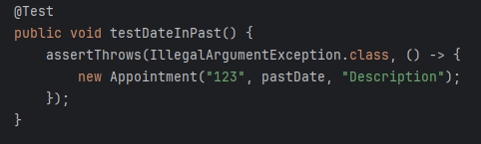
Also proper code coverage ensures that nothing is missed. Throughout all of this software, my code remained above the industry standard margin of eighty percent coverage.
Remaining disciplined to quality when creating code is extremely important. Taking shortcuts and cutting corners leads to messy code that may contian errors or bugs and generates more work for yourself and or others down the line. This wastes time, money, and resources. All of this can easily be avoided by remaining disciplined. The cost and time wasted is known as technical debt. Following indusrty best practices, thorough testing, and not cutting corners are all good ways to avoid this technical debt. For example, making sure my code was efficient and well written essential for making sure the final deliverable was a product that I could be proud of.

